Interview Notes
Key Themes
• The company is moving towards better use of data, but many processes are still manual.
• The fleet system is tightly optimised, with limited spare trains available.
• Fleet availability management is currently mostly reactive rather than predictive.
• Several factors affect fleet availability, including component wear, suppliers, depots, and weather.
• Train cancellations have significant financial and reputational impact.
1. Company Context
• Digital operations team established around 5 years ago
• Data Science team is around 3 years old
• 200–300+ systems generating operational data
• Historically slow data access
• Company is now building centralised data infrastructure
2. Fleet Context
• Around 250 total trains
• Around 150 trains required operational daily
• Limited spare rolling stock
• 25% timetable capacity increase
• System now tightly optimised
3. How Fleet Availability is Currently Managed
• Largely reactive approach
• Heavy manual maintenance checks
• Sensor data exists but is underused
• Engineering team not strongly data-driven
• No integrated predictive system
4. Causes of Availability Risk
Wheel / Traction Wear
• High wear components
• Can degrade gradually
• May not be picked up early
Supplier Differences
• Some fleet classes better supported than others
• Response speed varies
Maintenance Schedules
• Regular checks exist
• Unpredicted failures still occur
In-Service Failures
• Failures can occur during operation
• Trains may be removed mid-service
• Can create cascading operational impact
Depot Constraints
Main depots mentioned:
• London
• York
• Edinburgh
Analysis could potentially be done at depot level.
Weather and Track Interaction
Examples mentioned:
• Snow
• Flooding
• Animals on track
These are mostly managed reactively.
5. Financial Impact
• Train cancellation cost around £10,000+ per train
• Reputation damage
• Performance penalties
6. System Characteristics
• Tightly coupled network
• Limited flexibility during peak times
• Regulatory constraints limit reshuffling
• Some days allow flexibility, others do not
Through the interview, for us as a group it provided us with useful insight into the London North Eastern Railway and the operational challenges that come along with it. Fleet availability management is currently largely reactive, this is mostly because of the heavy reliance on manual maintenance checks and limited use of available sensor data. The interview gave is an insight on that they have a very limited spare capacity if things do go wrong, meaning that even small failures can quickly lead to cancellations and wider disruption. Several risk factors were mentioned, including component wear, supplier response times, depot constraints, and environmental factors such as weather or track obstructions. From these insights such things as operational data and predictive approaches could help them identify the risks a lot earlier and help them with fleet availability.
Risk analysis
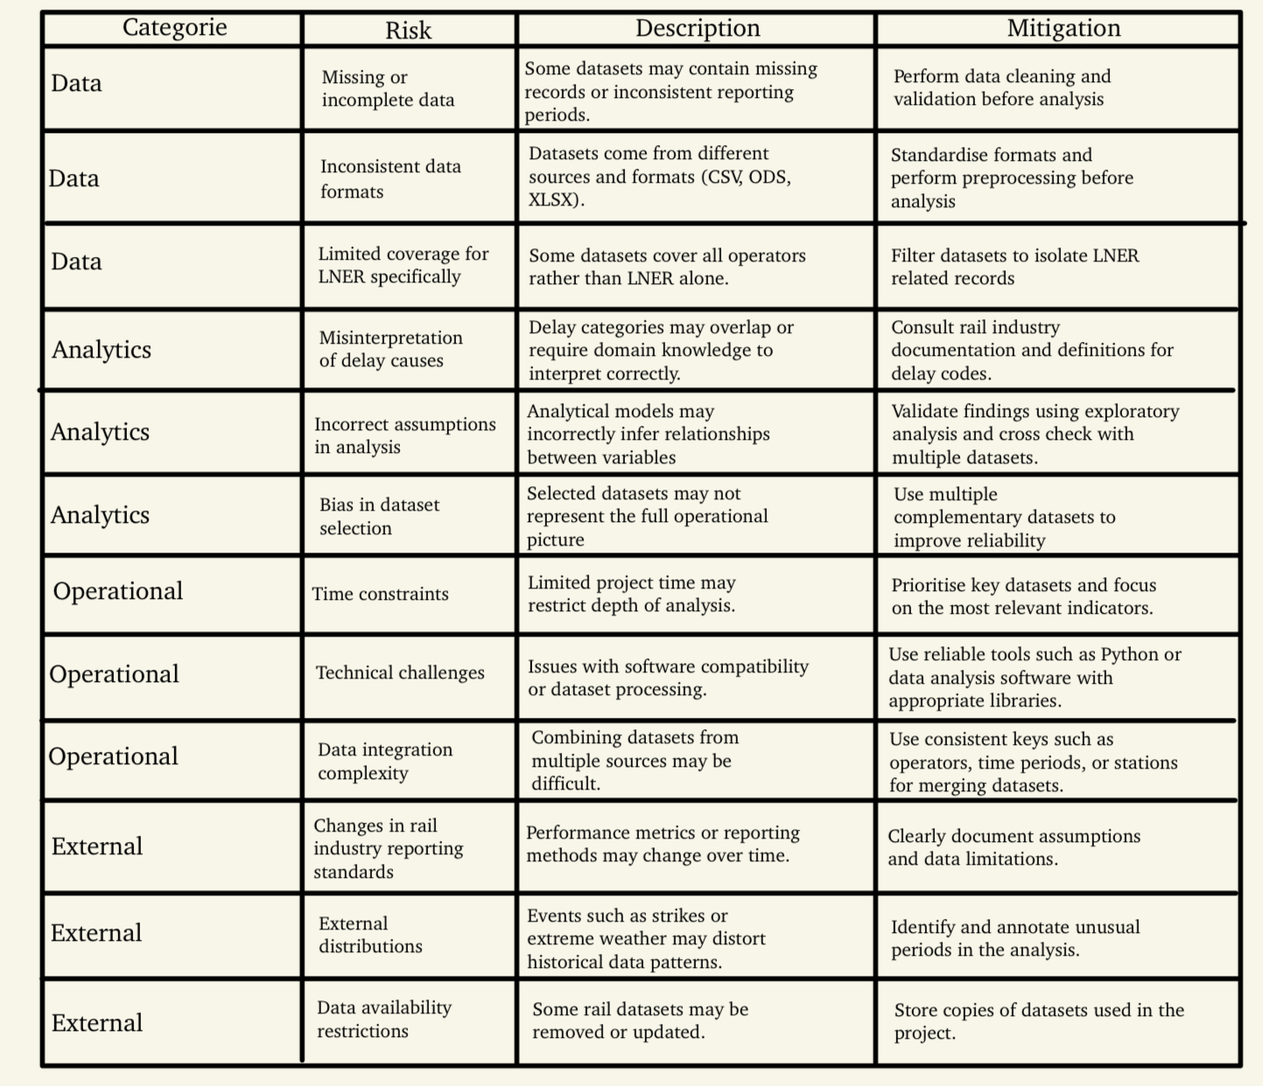

Background and Problem Domain
London North Easter Railway operates long distance passenger rail services across the East Coast Main Line. Core routes link London, York, Leeds, Newcastle, and Edinburgh. Reliable train availability supports daily operations. Fleet performance affects timetable delivery, passenger satisfaction, and financial performance.
Current operations depend on a fleet of around 250 trains. Around 150 trains run in daily service. Spare rolling stock remains limited. A recent timetable increase of 25 percent placed additional pressure on fleet availability. The operating system now runs close to capacity during peak periods.
Service disruptions create direct financial impact. A single cancellation costs around £10,000 or more. Repeated disruption damages brand reputation and triggers performance penalties. Operational teams therefore focus on maintaining reliable train availability across the network.
Fleet management still relies on reactive processes. Engineering teams perform frequent manual maintenance checks. Sensor data exists across multiple onboard systems. Data usage within engineering decisions remains limited. A predictive fleet availability system does not exist within current operations.
Technical factors influence fleet reliability. Wheel and traction components experience continuous wear during operation. Gradual degradation increases failure risk. Unexpected failures remove trains from service during operation. Such events trigger cascading disruption across tightly scheduled services.
Operational context adds further constraints. Depots in London, York, and Edinburgh support maintenance activity. Depot capacity and location influence repair turnaround times. External conditions also affect reliability. Snow, flooding, and animal strikes create additional operational risk.
The organisation collects large volumes of operational data from more than 200 internal systems. Centralised data infrastructure development now supports improved access to operational datasets. Analysis of historic performance data, delay causes, and fleet activity supports identification of reliability patterns. Insights from such analysis support earlier detection of risk factors affecting fleet availability.

